Cheetah Track Club Membership Form 2019
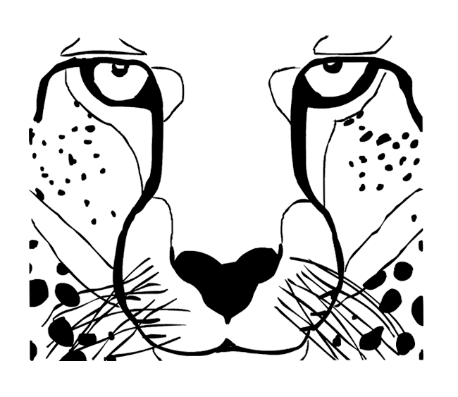
To be filled out by a parent or guardian. Please answer each question.
Participant’s Name:__________________________________Age:________
Birth Date:________________________________Male or Female________
Parent/Guardian Name:___________________________________________
Home Address:_______________________________________Zip_______
Home Phone:____________________________Work/Cell:_______________
Emergency Contact:____________________________Phone:____________
Physician Name________________________________Phone:____________

I understand that as parent and/or legal guardian. I am totally responsible for the medical care needs of_________________________________________ and the Cheetah Track Club is and will not be liable for any accident and/or illness that might occur to said child while involved in the Cheetah Track Club related activities.
In the case of medical emergencies, I understand that every effort will be made to contact parents(s) or guardian(s). In the event I cannot be contacted, I hereby give permission for emergency first aid administered to my child including hospital and/or clinic emergency room treatment.

Signature Date:
Does your child have any physical handicaps, allergies, or health conditions that may affect participation in workouts or track meets of which we should be aware? Please explain.
____Asthma__________________________ ____Diabetes_____________________________
____Upset Stomach____________________ ____Fainting/Dizzy Spells____________________
____Nosebleeds_______________________ ____Seizures_____________________________
____Food/Drug Allergies________________ ____Insect Bite Allergies____________________
____Upper Respiratory (i.e. Bronchitis, Pneumonia, Bronchiolitis) ____Other___________________

Is your child taking any prescribed medications? Yes_____No_____
If yes, will they be taken during Cheetah Track Club activities?_____________________________
MEMBERSHIP________________UNIFORM________________T-SHIRT___________________

